**SMART HEALTH MONITORING SYSTEM**

**INTRODUCTION**

COVID-19 pandemic has devised a fearsome impression on the whole world. Although in India, several institutions studied the extent of this life-threatening disease, the population of our country makes it more essential to have a closer look individual level. The world is currently facing a pandemic for the past two years. The symptoms of COVID-19 include mild fever, coughing, sore throat to high fever, exhaustion, and breathing difficulties. Patients experiencing severe symptoms should seek hospital care as soon as possible to receive an immediate oxygen supply. Thus regular checking and analyzing Heart Beat and SPO2 nowadays is very much essential. So we came up with an innovative way where you can monitor your reading and your close ones at any time and anywhere around the world.

Here we have developed a Health Monitoring Device that can measure heart rate in BPM (Beat Per Minute) and SpO2 (percentage of oxygen in the blood). The device monitors the heart rate and blood oxygen levels by placing a finger on top of the device. We can connect this device to the Blynk app that will record and regularly update the data for both SPO2 & BPM on the internet. Anyone can monitor the data from any part of the world.

As the pulse oximeter available in the market is very expensive. We tried to build the device in a simple & low-cost pulse oximeter. So let us see how to use MAX30100 Pulse Oximeter with ESP8266 to analyze individuals reading.

**COMPONENTS REQUIRED**

* **ESP8266**

The ESP8266 is a low-cost Wi-Fi microchip with a full TCP/IP stack and Microcontroller capability. The Wi-Fi module is a self-contained SOC with an integrated TCP/IP protocol stack that can give any microcontroller access to your Wi-Fi network. The ESP8266 is capable of hosting an application on offloading all Wi-Fi networking functions from another application processor connecting to the Wi-Fi module through a TP-Link WR841N router. It can ping the module at 479m with a rubber duck antenna soldered on or 366 meters with the PCB antenna.at 479m with a rubber duck antenna soldered on or 366 meters with the PCB antenna.

* **Max30100 Pulse Oximeter**

Max30100 is an integrated pulse oximeter and heart-rate monitor sensor solution. It’s an optical sensor that derives its readings from emitting two wavelengths of light from two LEDs. The pin configuration of Max30100 Pulse Oximeter Heart Rate Sensor Module is:-

|  |  |  |
| --- | --- | --- |
| **Sl. No.** | **PINS** | **DEFINITION OF PINS** |
| 1 | VIN | Input Voltage (1.8-5.5)V |
| 2 | SCL | IIC-SCL |
| 3 | SDA | IIC-SDA |
| 4 | INT | MAX30100 INT |
| 5 | IRD | MAX30100 IR_DRV |
| 6 | RD | MAX30100 R_DRV |
| 7 | GND | GROUND |

* **OLED**

An organic light-emitting diode, also known as an organic electroluminescent diode, is a light-emitting diode in which the emissive electroluminescent layer is a film of organic compound that emits light in response to an electric current. The primary component in an OLEDs display is the OLED emitter-an organic (carbon-based) material that emits light when electricity is applied. The basic structure of an OLED is an emissive layer Sandwich between a cathode and an anode.

* **Breadboard**

1. A **breadboard** is a widely used tool to design and test circuits capable of connecting electronic components such as transistors, resistors, chips, sensors, etc. There are several holes on the plastic box, arranged in a particular fashion. A typical breadboard layout consists of two types of region:- i) bus strips, ii) socket strips.
2. Bus strips provide a power supply to the circuit. It consists of two columns, one for power voltage and the other for ground.
3. Socket strips hold most of the components in a circuit. Generally, it consists of two sections each, with 5 rows and 64 columns.

* **Jumper wires**

A jump wire is an electrical wire or group of them in a cable, with a connector or pins at each end, which is normally used to interconnect the components of a breadboard or other prototype or test circuit, internally or with other equipment or components, without soldering.

* **Blynk App Protocols**

Blynk is an open source android app which is designed and developed in order to control the hardware via internet of things (IOT). This digitally displays sensor data, it can accumulate and visualize the data. This app gives us to create amazing interfaces for a project using multiple widgets which is an in build app. It acts as an interface between the smartphone and hardware which is responsible for the communication.

**FLOWCHART**

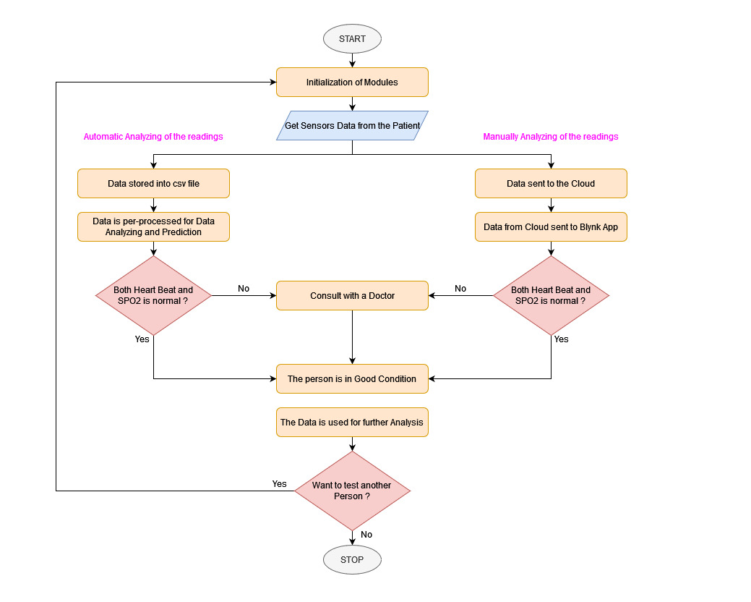

**CIRCUIT DIAGRAM**

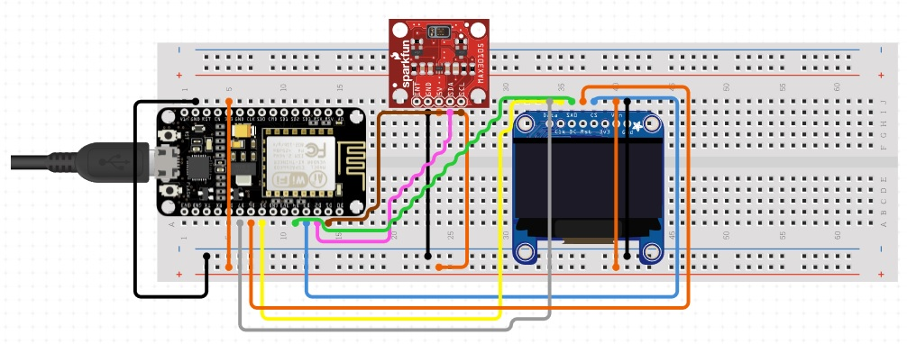

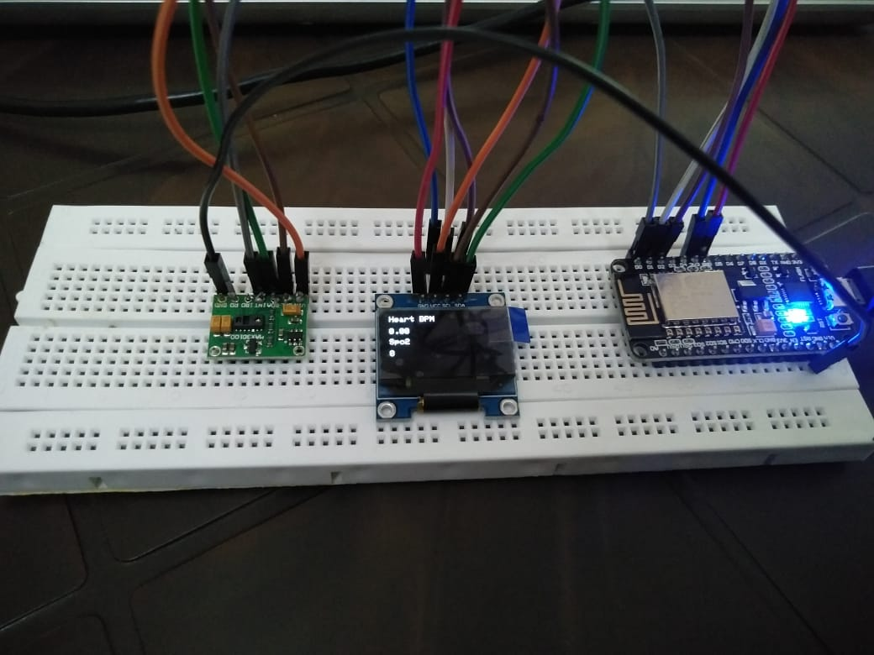

**SCHEMATIC DIAGRAM**

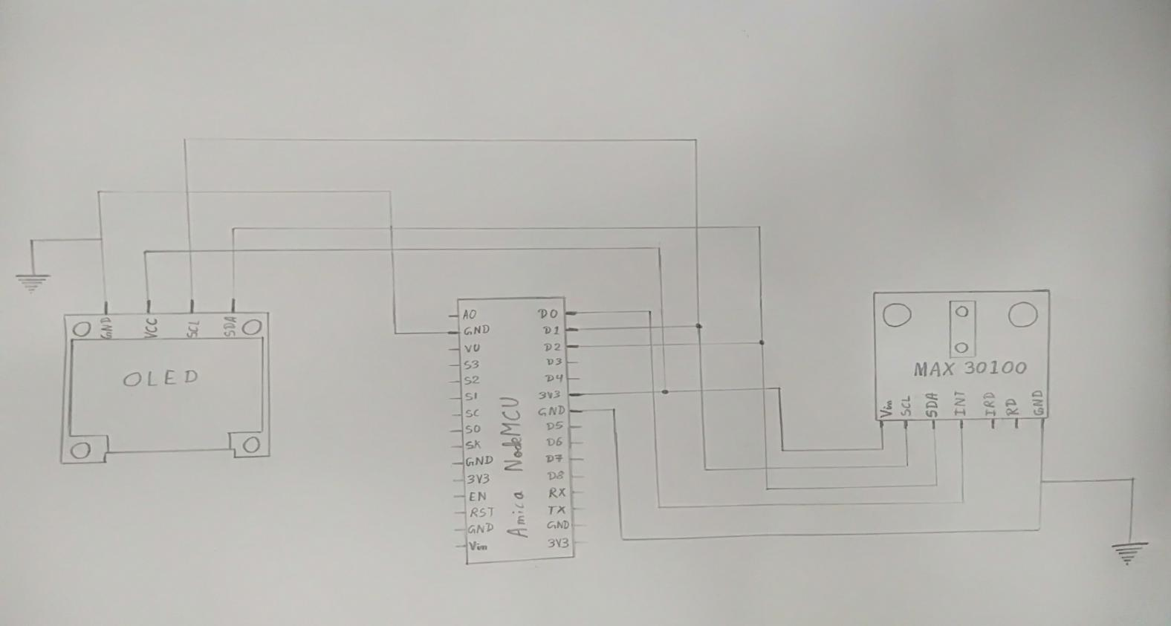

**VISUALIZING THE DATA USING BLYNK APP**

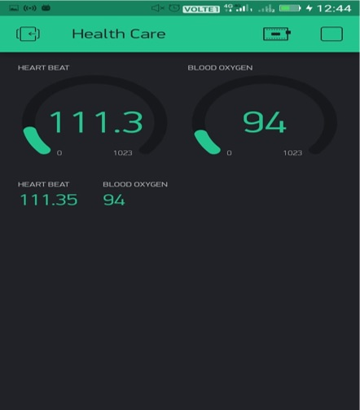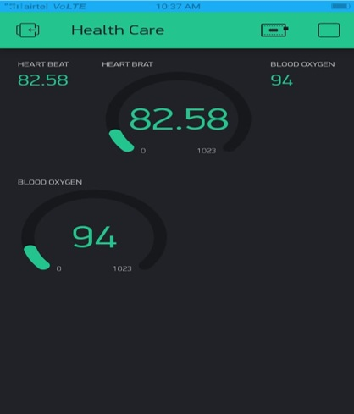

Here we have taken the reading from one person’s finger and displayed to the data using Blynk app to two different devices having Blynk app with the same credentials simultaneously. The value displayed in the Blynk is different as the sensor is taking the reading continuously and changing after every time period.

**DATA VISUALIZATION**

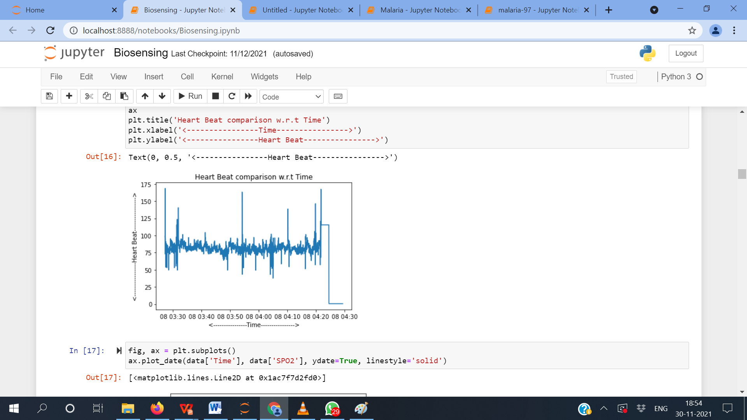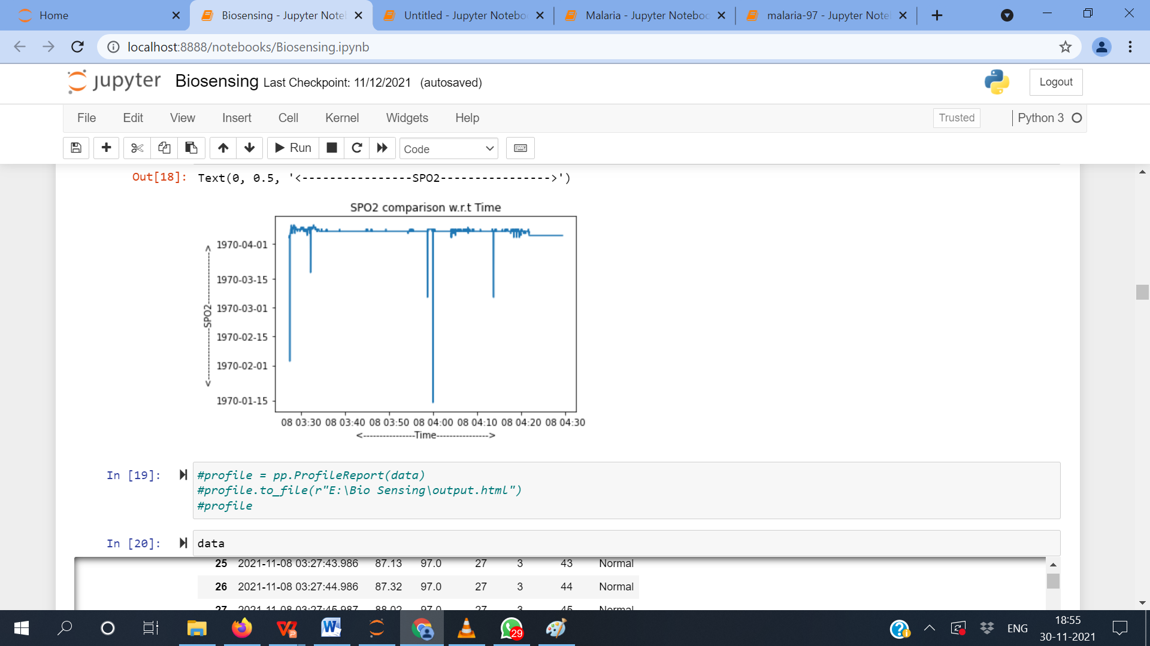

The above two plots demonstrate how the Heart Beat and SPO2 change every second. By observing the plots, we can conclude that the sensor is not 100% accurate and needs more improvement in connectivity, or we need to place the finger properly.

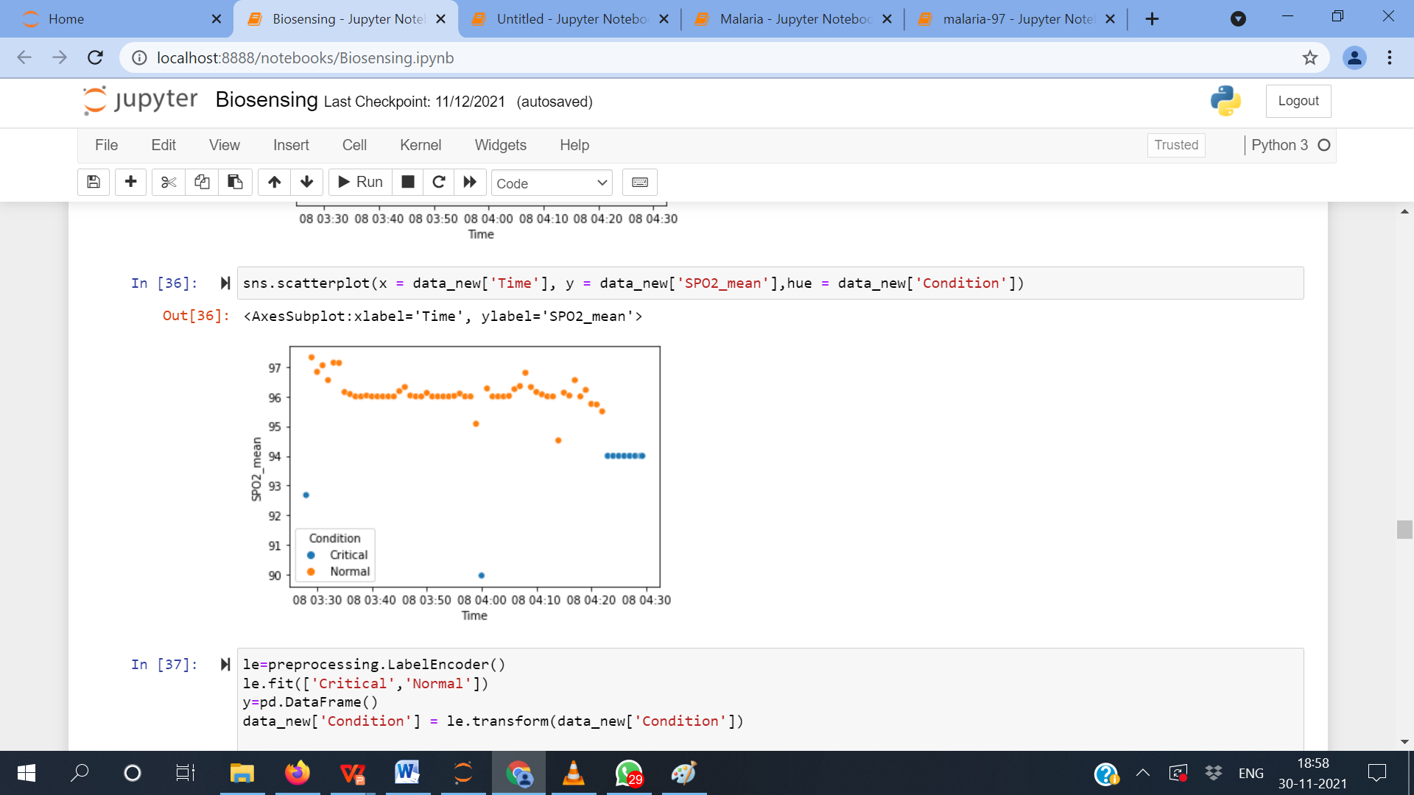

In the above plot, we can see that the sensor is lagging to take the current readings instantly, and in the end, the sensor continues to note some reading (garbage values) though there was no figure at that moment. In the middle of the plot, we can see a blue dot that shows the person needs medical attention. But the person who kept his finger on the sensor was doing well.

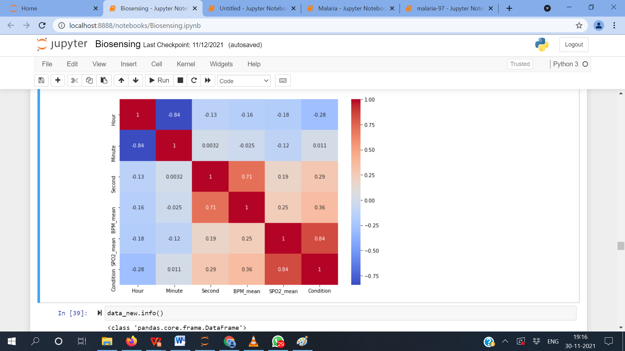

In comparison to all the features we have in our dataset, we can see by the correlation matrix that our model is giving more priority to SPO2 and less to Heart Beat (BPM), which might be disastrous in the real-world scenario. By observing this visualization, we need to emphasize further labeling the target feature concerning the Heart Beat and SPO2.

Thus, by all the assumptions, we can see how with the help of Data Science, we can decide whether the device is market-ready or not.

**CHECKING THE MACHINE LEARNING MODEL PERFORMANCE**

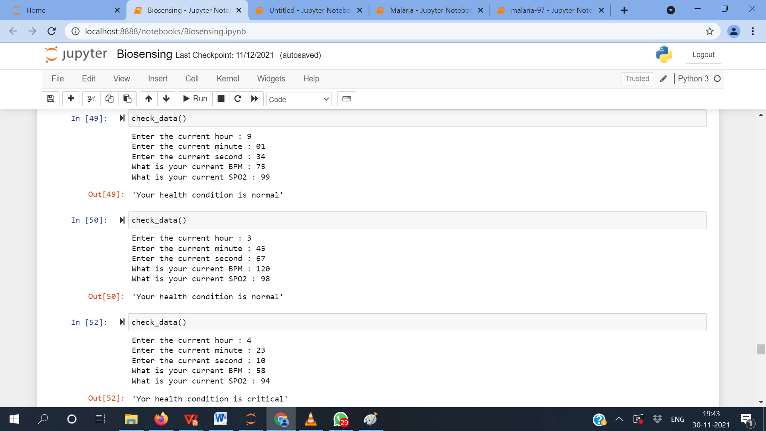

From the prediction by our ML algorithm, we can see how the model fails to categorize the person as critical when the Heart Beat reading is too high but does well on the other two instances.

**SUSTAINABILITY**

By definition, sustainability aims to promote healthy, viable, and equitable communities. The challenge is the current approach to delivering health and care cannot continue in the same way and stay within these limits. A sustainable health and care system is achieved by delivering high-quality care and improved public health.

**PROJECT’S ADVANTAGES**

* Allows sending data from patients to health professionals in real time.
* Improves patient’s lifestyle.
* Makes health care more available.
* Saves money.
* Treatment and detection of illness becomes faster.

**CONCLUSION & FUTURE WORK**

In this article, we discussed the importance and benefits of using the Internet of Things and Data Science in Smart Health Monitoring Systems. It will have a positive impact on every patient’s life, that even though they are away from home and physician, this helps them to reduce the fear of illness. The data can be stored and analyzed from any environment. The challenges in sensing and prediction are highlighted, which can be solved to provide seamless benefits to the medical field.